**Russian Constructivism**

Russian Constructivism was a cultural movement that emerged from the ferment of the Bolshevik Revolution of 1917. Responding to the advent of the ‘Machine Age’, Constructivism helped to formulate an aesthetic inspired by machines and adapted to the needs of a modern, industrial society. It thereby had a profound impact upon Modernist architecture and design in the West, influencing both the BAUHAUS and the DE STIJL movement. Constructivists saw themselves as artist-engineers working in service to the new society and the movement briefly enjoyed the support of the Bolshevik Government, which commandeered this modern, abstract style to express its ideals. Constructivism was manifested in many cultural fields, including art, architecture, graphic design, theatre and cinema.

The origins of Constructivism lay in the pre-Revolutionary work of VLADIMIR TATLIN, an artist and architect based in Moscow. Inspired by CUBISM and ITALIAN FUTURISM, Tatlin created abstract geometric constructions or ‘painterly reliefs’ using industrial materials such as steel, iron and glass. The sculptors Antoine Pevsner and Naum Gabo published a *Realistic Manifesto* in 1920, which further articulated this approach. The term ‘Constructivism’ is thought to have been derived from the manifesto, although other sources have been suggested. Constructivism was consolidated as a movement at INKhUK (Institute of Artistic Culture) in Moscow. The First Working Group of Constructivists was founded here in 1921 and included Alexei Gan, Liubov Popova, ALEXANDR RODCHENKO, Varvara Stepanova and ALEXANDR VESNIN, all of whom were committed to a materialist and politically-orientated approach. Important outlets for Constructivism were the journals *LEF* (1923-5) and *Novyi LEF* (1927-9), launched by the Left Front for Artists.

The Constructivists were among the first artists to be entranced by the new age of machinery and technology. In this period, Russia was still largely a rural, peasant country with little heavy industry, but the Bolshevik Revolution promised a workers’ paradise built with modern technology. In this climate of political fervour, the machine became a powerful metaphor for progress. Constructivism celebrated the machine for its visual and symbolic properties, developing a machine aesthetic that was later extended at the Bauhaus.

Anticipating a proletarian Utopia, many Constructivists worked in service to the Revolution. They rejected the notion of art as the preserve of bourgeois society and were determined to demolish the barriers between art and industry. The propaganda value of their dynamic constructions and graphics was recognised by the State and numerous agencies were set up to cultivate it. For example, Narkompros, the People's Commissariat of Enlightenment, was a cultural and educational ministry headed by Anatoliy Lunacharsky. Vladimir Tatlin was appointed director of IZO (the visual art section of Narkompros) and became a key figure in the implementation of Lenin’s Plan for Monumental Propaganda. Constructivists were recruited to create Agitprop (agitation-propaganda) trains that toured the country emblazoned with striking graphic designs, thereby spreading the revolutionary message to Russia’s largely illiterate population.

Tatlin believed that design was linked to engineering and saw the designer as an anonymous worker whose task was to serve society. He designed the Monument to the Third International (1919-20), which was envisaged as a 396m tower of iron, glass and steel. This visionary design represented the union of art and construction – its sculptural form of two intertwining spirals and a soaring diagonal component was rendered in a lattice construction suggestive of engineering. The tower also functioned as a machine, featuring four transparent volumes that rotated at different speeds (yearly, monthly, daily and hourly). These were intended to house government offices for legislation, administration, information and cinematic projection. High costs and political opposition prevented Tatlin from executing the design, and only a scale model was ever built. Tatlin subsequently directed his talents into industrial production, with only limited success, creating designs for an economical stove, furniture and workers' overalls.

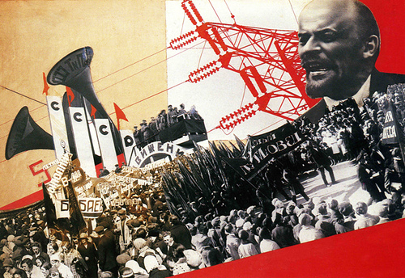

Varvara Stepanova , *The Results of the First Five-Year Plan* (1932).

<http://kayleighmahon.files.wordpress.com/2011/10/573033730_2e65f49b7a.jpg>

Initially, Constructivism was concerned with three-dimensional constructions, but the aesthetic was soon extended to other media. The graphic designer Varvara Stepanova developed a powerful visual style charged with energy and dynamism. She also designed workers’ clothing and textiles, many of which were mass-produced by the First State Textile Printing Factory from 1923 to 1924. Her contribution to the publication *The Results of the First Five-Year Plan* (1932) mythologized the technological achievements of Stalin’s first programme of economic reform. Stepanova’s husband Alexandr Rodchenko was a painter and graphic designer who created propaganda posters, book covers and state advertising in a similarly dynamic style. He experimented with photography and photomontage, and designed inter-titles for Dziga Vertov’s film *Kino Eye* (1924). Photomontage was analogous to editing in film and directors such as Vertov and Sergei Eisenstein began experimenting with dynamic editing techniques based on the juxtaposition of jarring images. Films such as Eisenstein’s *Battleship Potemkin* (1925) can be regarded as ‘Constructivist.’

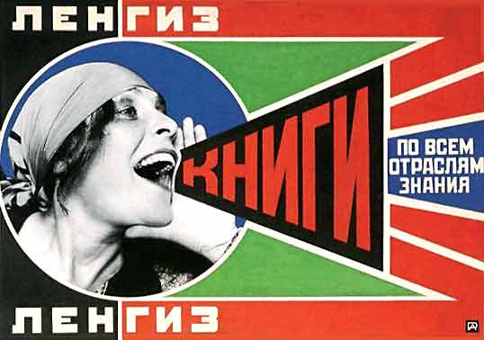

Alexandr Rodchenko, Poster for a Moscow publisher, 1924

<http://www.creativereview.co.uk/images/uploads/2008/08/rodchenko.jpg>

Architecture was a crucial area of Constructivist practice as it was directly concerned with building the infrastructure of the new society. The VESNIN brothers LEONID, VIKTOR and Alexandr developed a Constructivist approach to architecture in buildings that emphasized functionalism and new construction techniques. However, many of their projects remained un-built due to the technological limitations of the day.

Political support for Constructivism waned after 1932, when Stalin outlawed abstract art and imposed the doctrine of Socialist Realism. This severely curtailed Constructivist activity, although some exponents continued to produce innovative work, particularly in the fields of poster design and typography.

**References and further reading**

## Cohen, J.L. and Lodder, C. (2011) *Building the Revolution: Soviet art and architecture, 1915-1935*. London: Royal Academy of Arts. (A stimulating text that illuminates the relationship between art and architecture in the immediate post-Revolutionary period. Superb archival and modern photographs present Constructivist buildings in their urban context).

Dabrowski, M., Dickerman, L., Galassi, P. and Rodchenko, V.A. (1998) *Aleksandr Rodchenko*, New York: Museum of Modern Art. (Based on research in Russia, this comprehensive book examines one of the most important and versatile exponents of Constructivism).

Gough, M. (2005) *The Artist as Producer: Russian Constructivism in Revolution*, Berkeley: University of California Press. (A perceptive study of the Russian avant-garde and its political ambitions, focusing on the Institute of Artistic Culture [INKhUK] in Moscow, an important centre of Constructivist activity).

## Khan-Magomedov, S.O. (1987) *Alexandr Vesnin and Russian Constructivism*. Lund: Humphries. (A monograph on one of the major architects associated with Russian Constructivism).

Lodder, C. (1985) *Russian Constructivism*. New Haven: Yale University Press. (The first detailed account of Russian Constructivism, tracing its chronology and examining the work of key figures across a vast range of media. The volume also features the first comprehensive study in English study of VKhUTEMAS).

Margolin, V. (1997)*The Struggle for Utopia: Rodchenko, Lissitzky, Moholy-Nagy, 1917-1946*, Chicago: University of Chicago Press. (An examination of three major exponents of Constructivism, asking how they negotiated the tensions between their ideals and the political realities they faced).

Milner, J. (1983) *Vladimir Tatlin and the Russian Avant-Garde.* New Haven: Yale University Press. (Based on extensive research in the former Soviet Union, this volume places Tatlin’s work in a Russian context, examining the cultural and political forces that shaped it).

### Rickey, G. (1995) *Constructivism: Origins and Evolution*. New York: George Braziller. (A revised edition of this important early study of Constructivism. The book also examines a range of artists who, in Rickey’s view, perpetuated Constructivist principles around the world).